Week 2

|  |  |
| --- | --- |
| Name : SUNDEEP A | SRN: PES1UG20CS445 |
| SEC: H | ROLL NO : 48 |

**Designing and Simulation of Network Topology using Cisco Packet Tracer**

Task 1 (Demo):

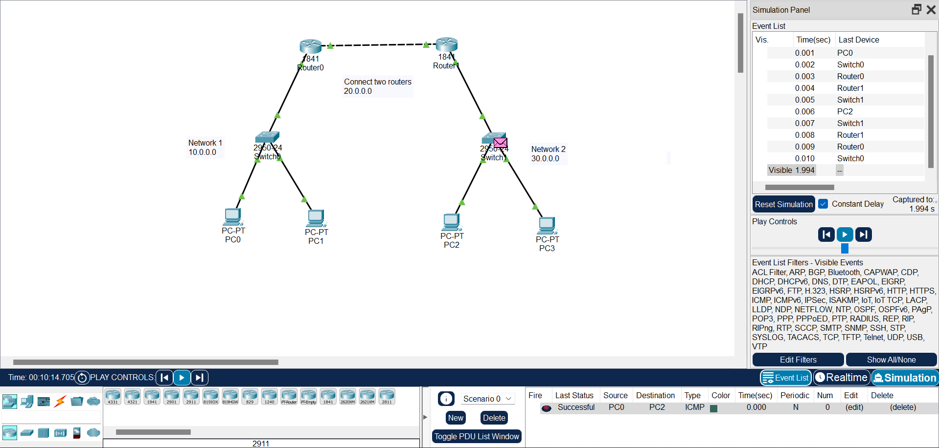

Here we can see that we have successfully sent from PC0 to PC2.

**Task 2:**

In the below figure we can see that We have successfully sent a simple PDU from PC0 to PC2

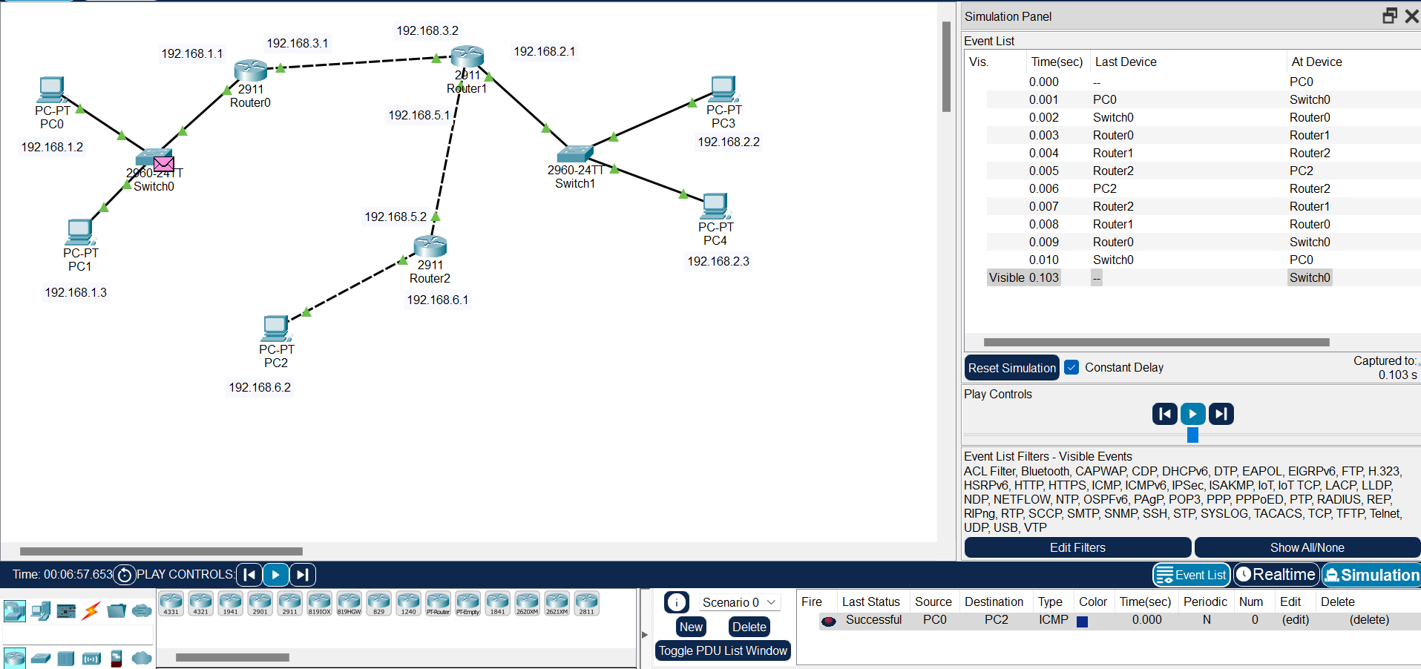

In the below figure we can see that we can see that We have successfully sent a simple PDU from PC0 to PC4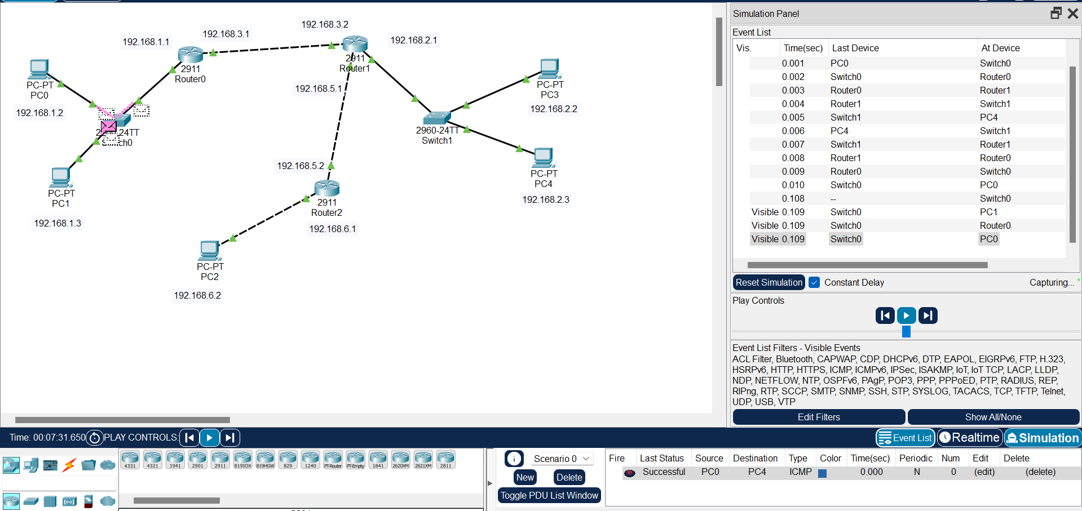

In the below figure we can see that we have successfully sent a simple PDU from PC2 to PC3